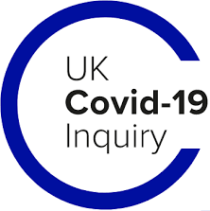

UK Covid-19 Inquiry

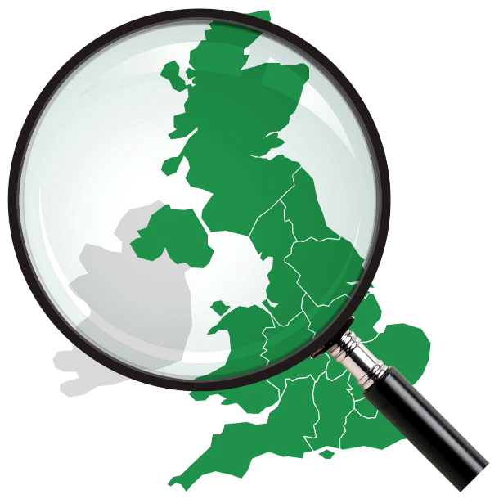
December 2025 Newsletter


Introduction

By Ben Connah Secretary to the Inquiry

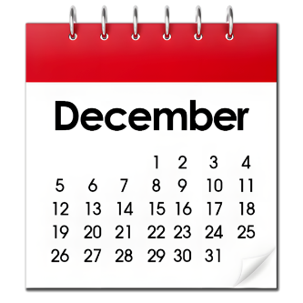
Welcome to our December newsletter. Read updates about:

- The Module 2 report

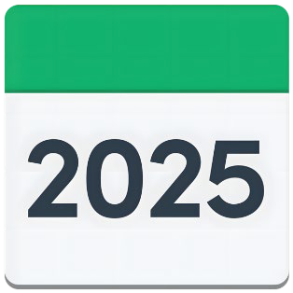
- Our work in 2025

- Module 9: money

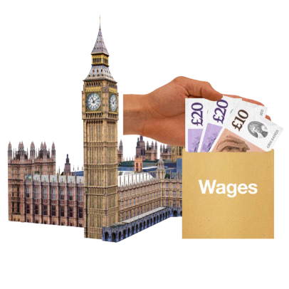
- Module 10: society

- The Inquiry’s recommendations

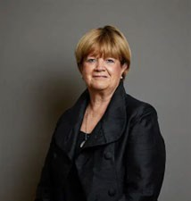
- Remembering the pandemic

- Baroness Hallett’s Lifetime Achievement Award


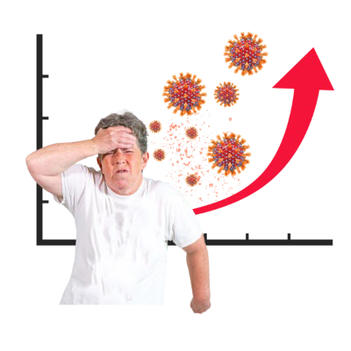
Module 2 report

Use this link to find the
short and accessible versions

Module 2 was about the decisions that governments made during the pandemic.

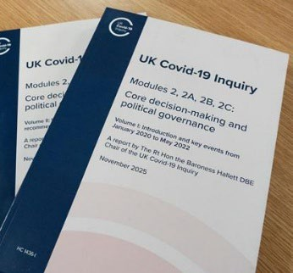
The Chair, Baroness Hallett, published her report last month.

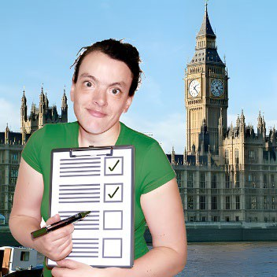
The report tells the UK’s governments what they need to do to prepare for the next pandemic.

Use this link to read the
full report.

Our work in 2025

2025 has been a busy year.
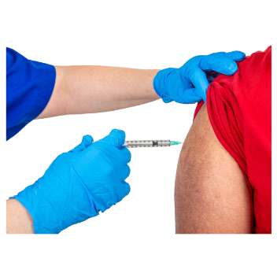
We held 6 sets of public hearings about:

- Vaccines

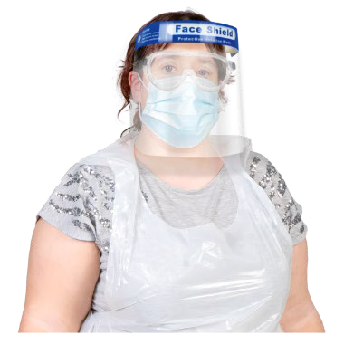
- Buying protective equipment called
PPE, and other health supplies

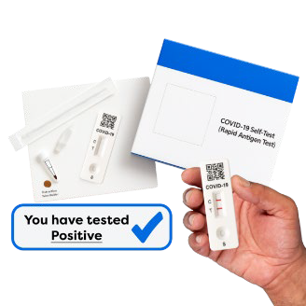
- Care at home and in care homes

- Test, trace, isolate

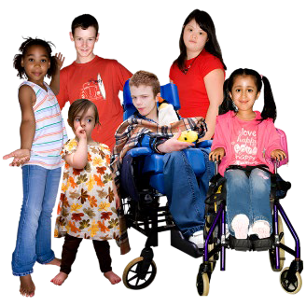
- Children and young people

Module 9: money


Module 9 is about decisions that were made about how to support people with money.

For example:

- Furlough: paying people when they could not go to work

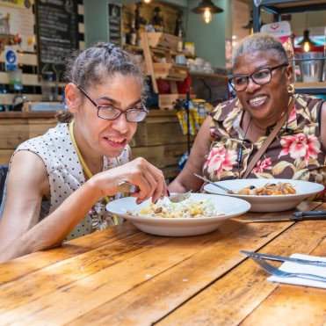
- Lending businesses money

- Eat out to help out, which made it cheaper for people to eat in pubs and restaurants

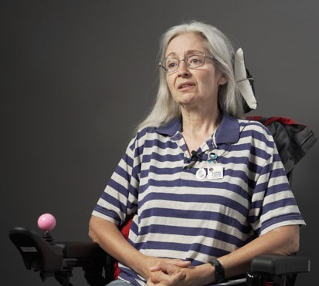
The hearings began with a film. It is about people’s experiences. Watch the film on YouTube.

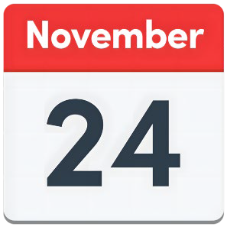
The Module 9 hearings started on

Monday 24 November.

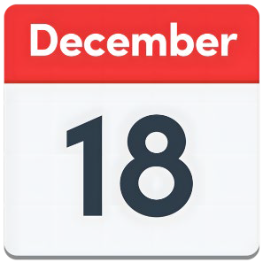
The hearings will end on

Thursday 18 December.


Watch the hearings on YouTube: https://www.youtube.com/ @UKCovid-19Inquiry

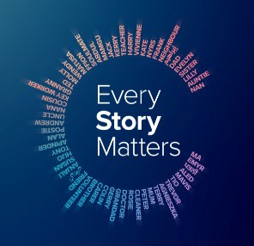
The Inquiry used the Every Story Matters Record about money as evidence. You can read it here:

https://covid19.public-inquiry.uk/documents/every-story-matters-economic-response-in-brief/

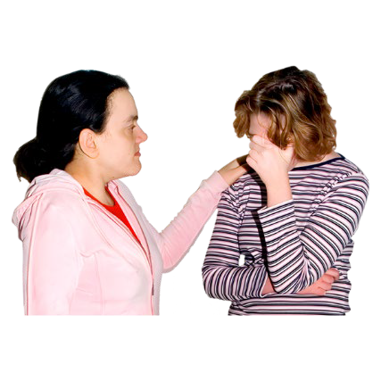

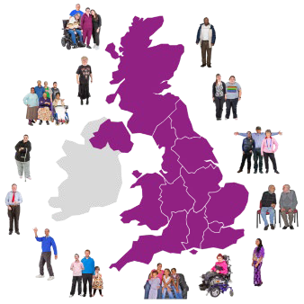
Module 10: society
- Mental health
- Wellbeing
Find out more from our website.

Module 10 is about how the Covid-19 pandemic affected society.
The hearings are in early 2026.

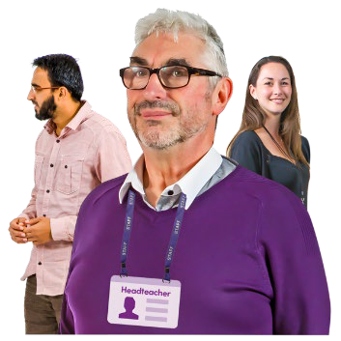
We will learn about:

- Key workers – teachers, transport workers, cleaners, shop workers

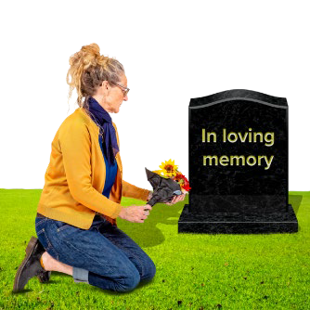
- Vulnerable people – people who were young, old, or disabled

- People who lost friends or family

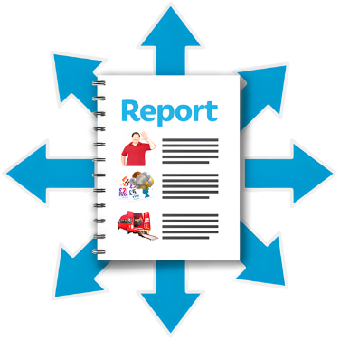
Our recommendations

Every Covid-19 Inquiry report has a list of recommendations from Baroness Hallet.

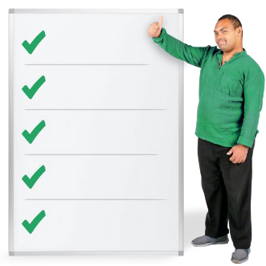
A recommendation is something that needs to be done, or changed, to help us deal with a pandemic in the future.




The recommendations are for the UK’s 4 Governments.


After each report is published, the governments should say what they will do about the recommendations.

Use this link to read more about the recommendations.


Remembering the pandemic
The UK Government has said what it will do to help people remember the pandemic, and the lives that were lost.


For example, there will be a National Day of Reflection in March every year.


The National Covid Memorial Wall
will be looked after.

Read about everything the UK government will do here:
Covid Commemoration - GOV.UK

Lifetime achievement award
Baroness Hallett is the Chair of the Covid-19 Inquiry. She has won a Lifetime Achievement Award.

She hears all the evidence at the
Covid-19 Inquiry and writes the reports.


She was a judge and has worked on important inquests. She also encourages other people to become judges.

Read more about the awards here: 2025 Women in Law Awards

