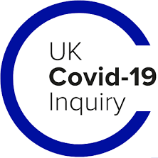

UK Covid-19 Inquiry

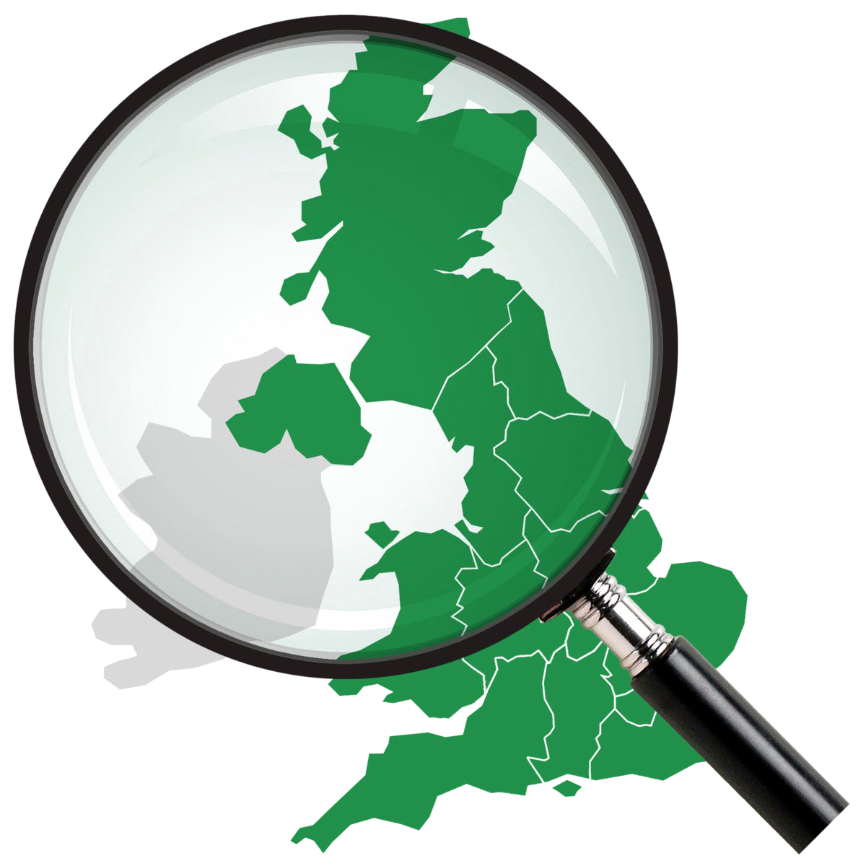
April 2024 Newsletter

Introduction
By Kate Eisenstein
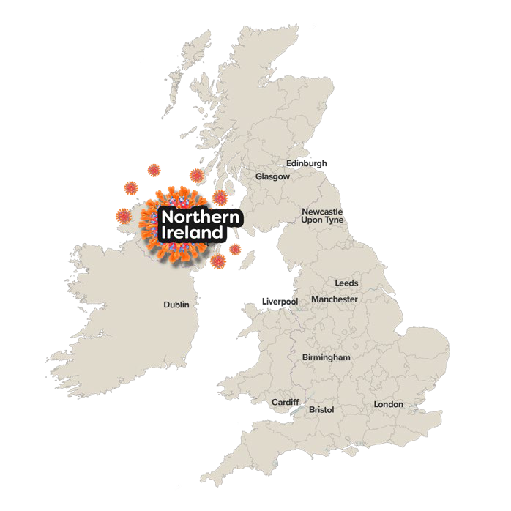
Director of Policy, Research and Legal

This newsletter will tell you about:

Hearings in Belfast
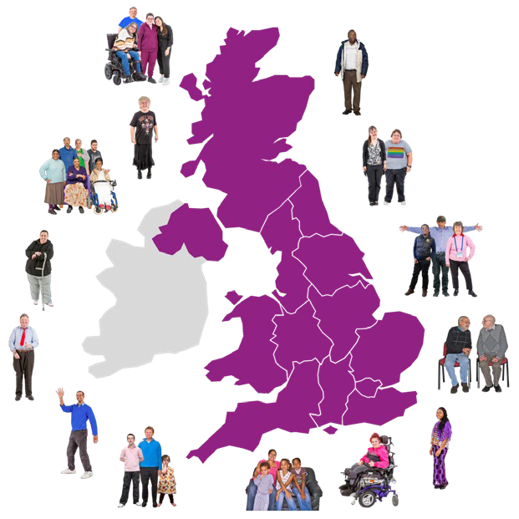
We are finding out about the pandemic in Northern Ireland.

Every Story Matters
People from all over the UK are sharing their experiences.

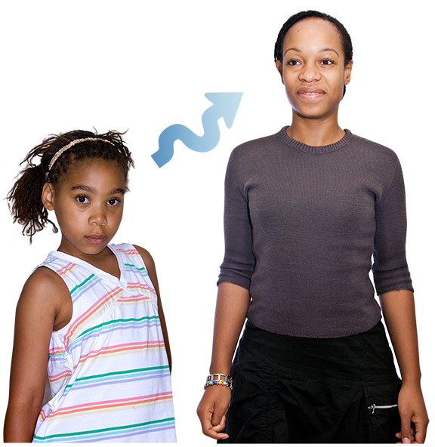
Children and Young People Voices We are listening to young people about their experiences of the pandemic.

About the enquiry

The Covid Inquiry is finding out

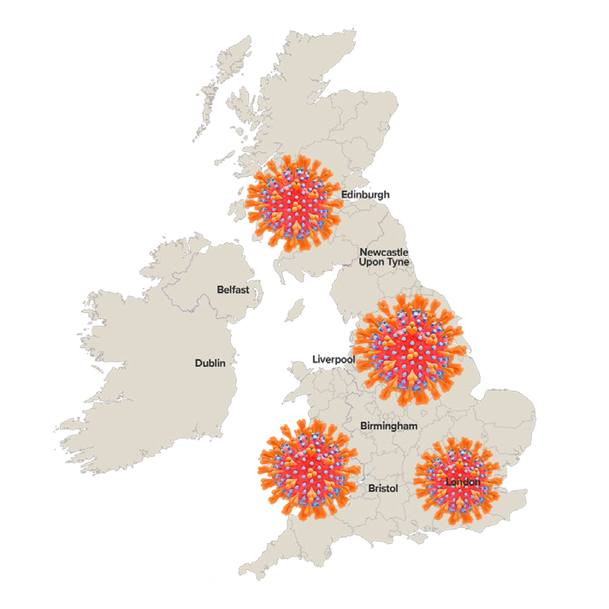
- what was done to prepare the UK before the pandemic

- how people were treated and protected during the pandemic

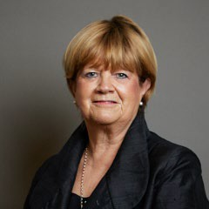
The Chair of the Inquiry is Baroness Hallett. She is writing a report about

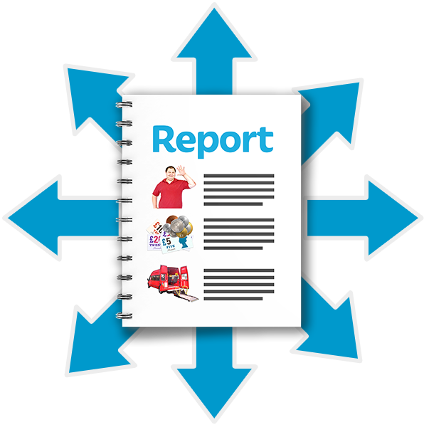
  - whether the UK was ready for a pandemic

  - recommendations to help us be ready for another pandemic

Hearings in Belfast

At a hearing, people tell us about their experiences and opinions of the Covid-19 pandemic.

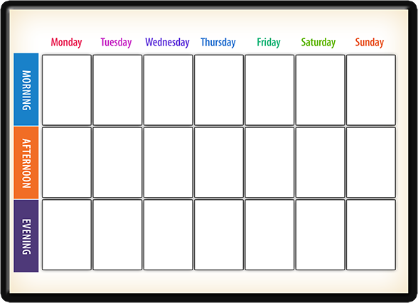
Hearings are happening in April and May at the Clayton Hotel in Belfast.

Dates: 30th April – 16th May

Link to information about the Belfast Hearing: https://covid19.public-inquiry.uk/ modules/core-uk-decision-making- and-political-governance-northern-
ireland-module-2c/

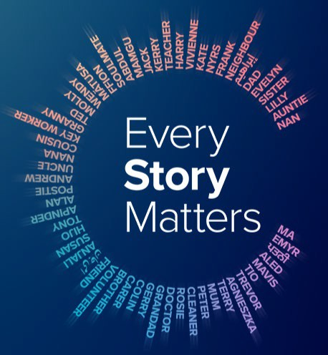
Every Story Matters

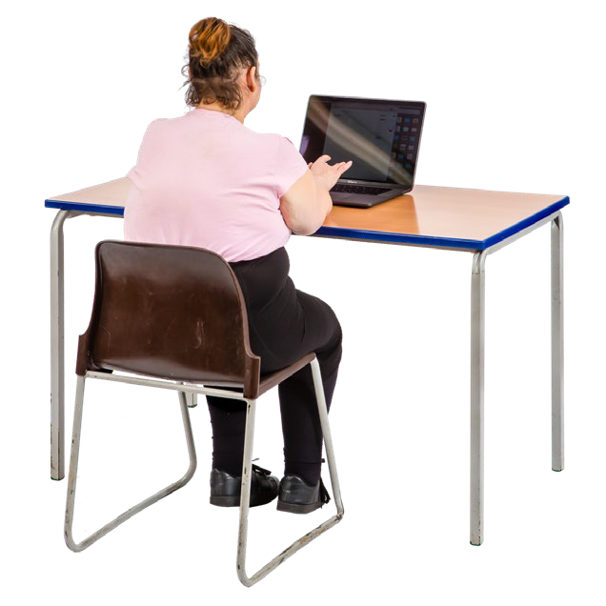
Anyone in the UK can tell us about their experience of the pandemic.

While the hearings have been happening in Belfast, we have been telling local people about Every Story Matters using adverts.

The adverts have been put in local newspapers and online.

Find out how to tell us your story: https://covid19.public- inquiry.uk/every-story-matters/

Every Story Matters: Events
In March and April, we heard pandemic stories from

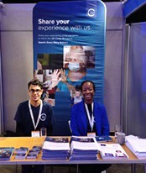
- child health experts
- disabled people
- teachers
- health workers
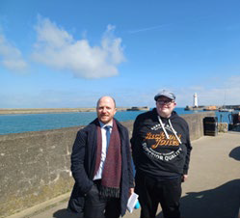
- carers

In May we will visit

- people living in rural communities in Northern Ireland
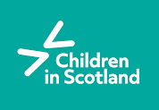
- students in Belfast
- people at the “Children in Scotland” conference

Children and Young People Voices
This is a new project. We will listen to hundreds of young people who are aged 9-22.

We want to find out about how the pandemic affected them.

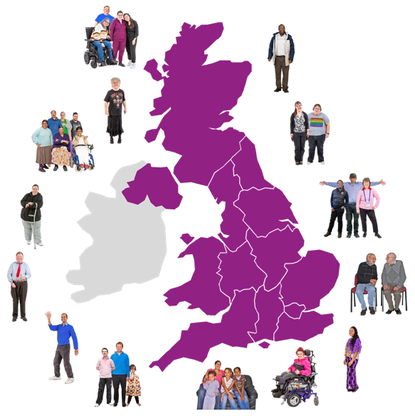
We will include young people
- from all over the UK
- who lost loved ones
- with disabilities
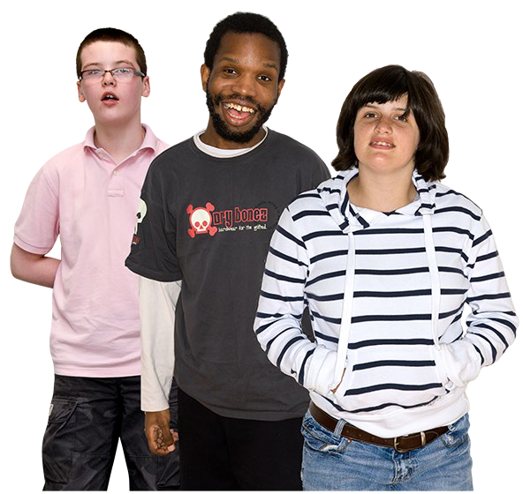
- who have had long covid
- who have a social worker or use mental health services
- from lots of ethnic backgrounds

Children and Young People Voices

Other organisations have already done research about the effects of the pandemic on young people.

We will look at their research as part of our project.

If you would like to tell us your own experiences, use the link to Every Story Matters on page 5.

Find out more about the project https://covid19.public-inquiry.uk/ news/hundreds-of-children-and- young-people-set-to-tell-the- inquiry-how-the-pandemic-
affected-them/

Bereaved Forum

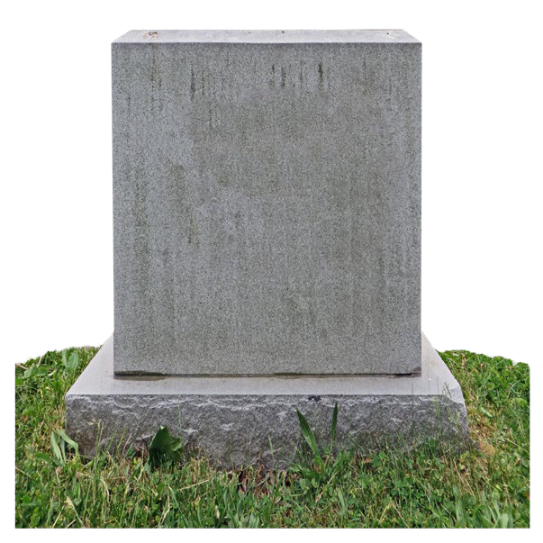
Being bereaved means that someone you love has died. The Bereaved Forum is for anyone who was bereaved during 2020-2022.

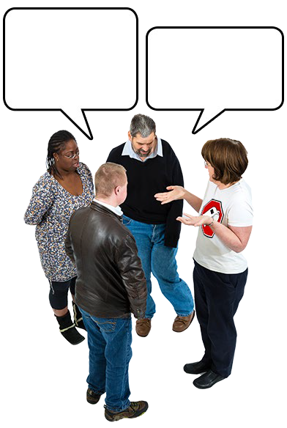
People on the bereaved forum will get a regular email about chances to give advice to the Inquiry on
- Every Story Matters
- our work to remember people lost to Covid-19

To join the forum, email us: engagement@ covid19.public-inquiry.uk

